**PRACTICAL NO – 6**

**Aim : Study Cloud Security Management.**

**Steps:**

1. **Click on link below-**[**https://aws.amazon.com/console/**](https://aws.amazon.com/console/)

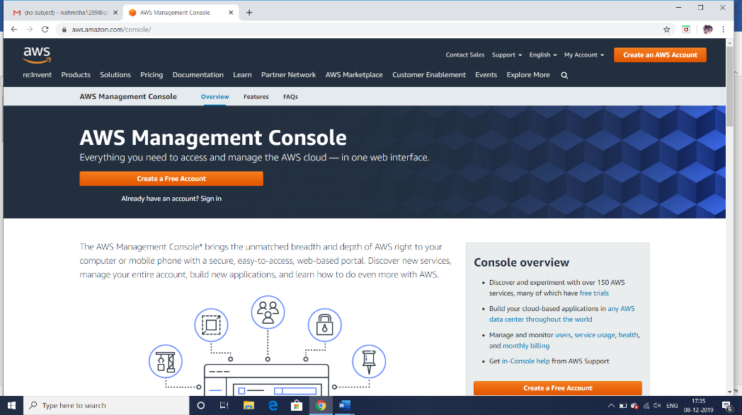

1. **Go to “My Account” > “AWS Management Console”.**
2. **Just login to your users account.**
3. **Then go to “IAM”.**

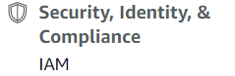

1. **Then go to Users.**

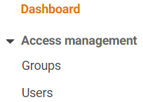

1. **Now click on the user to which you wish to give extra security .**

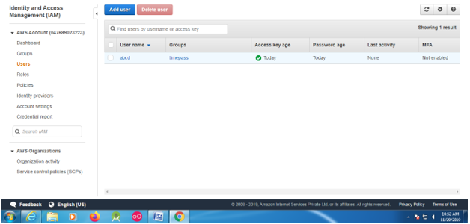

1. **Go to Security Credentials then go to Assigned MFA device and click on “Manage” .**

** 🡪 **

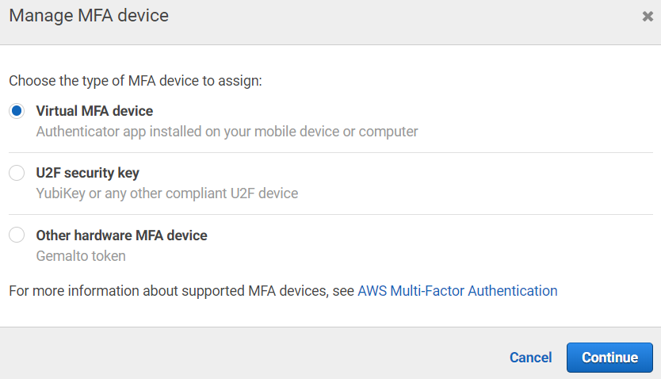

1. **Use “Google Authenticate” App to scan the barcode and obtain the MFA code.**

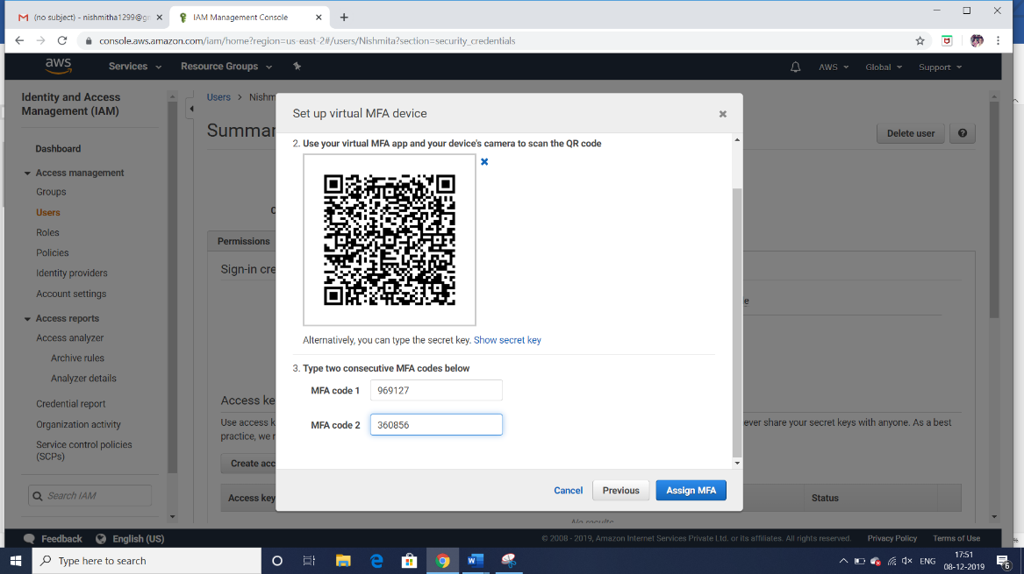

1. **You will get the confirmation message.**

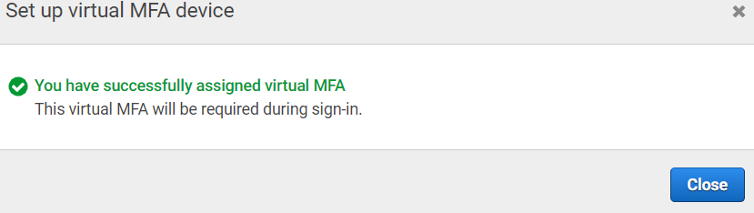

1. **Now logout from the root account and login to the user account.**
2. **Once you enter the username and the password, the system will ask you for MFA code .**

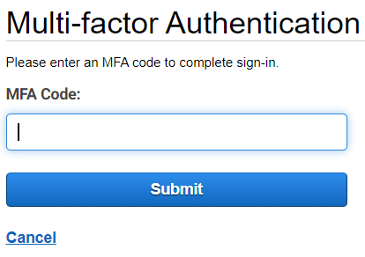

1. **Enter the MFA code and proceed further .**
2. **Login to your account now.**

